2013

International Exhibition of floriculture and green industry
“Flowers EXPO – 2013”
Russia, Moscow

The Winner of the Exhibition in the nomination «The best production quality».

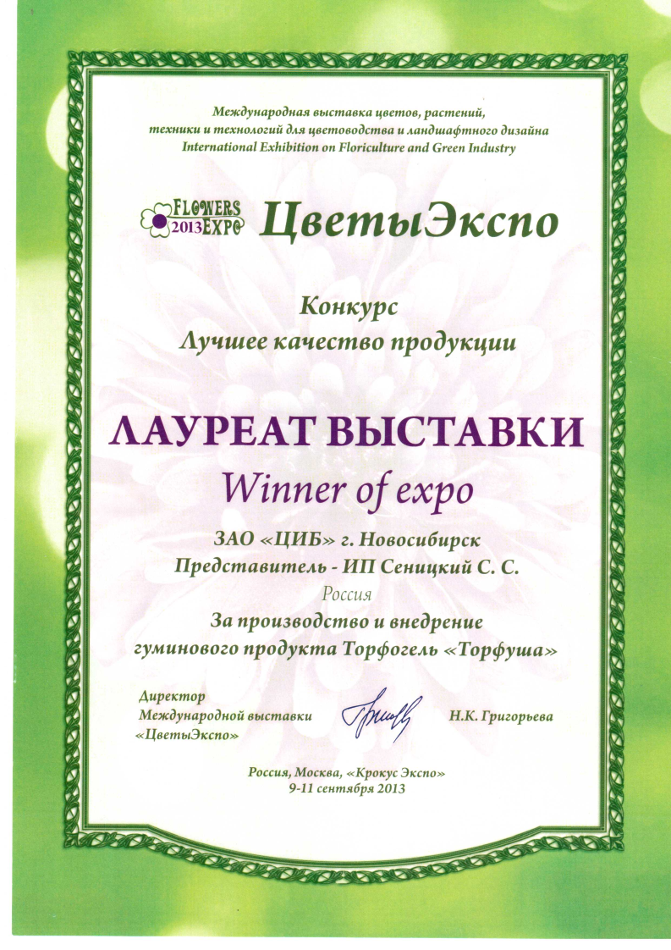

2 Gold Medals.
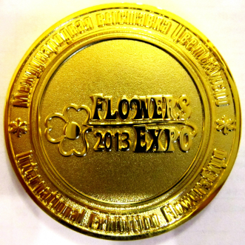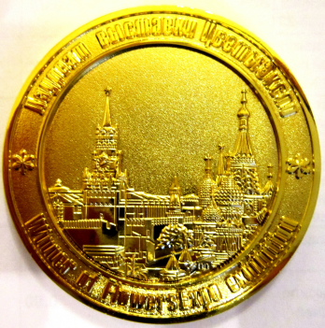

XX International Exhibition of flowers plants equipment and materials for ornamental gardening and flower business
Russia, Moscow

DIPLOMA in the nomination «The best quality of production.
Bronze medal.
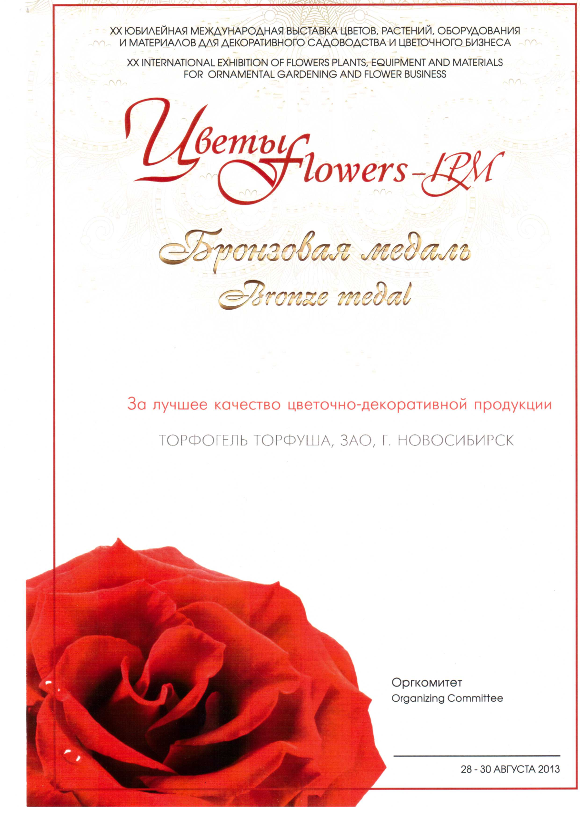

12-th International Specialized Exhibition
"Landscape architecture. Floristics"
Russia, Moscow

DIPLOMA
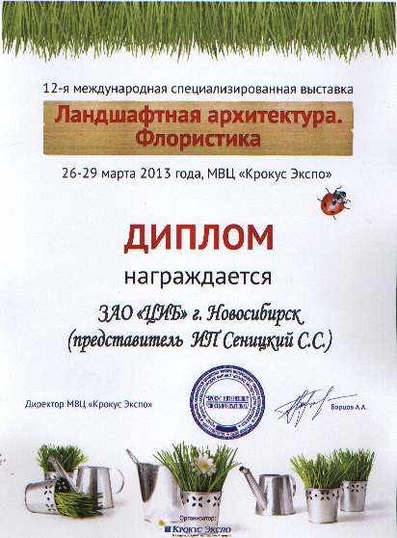

17-th specialized exhibition fair "Country-house. Garden. Landscape. Small mechanization – 2013”
Russia, Moscow

DIPLOMA for creation and production of high-quality natural peat fertilizers

