2010

Exhibition - Forum of domestic producers "Buy Russian"
Moscow, Russia

2 DIPLOMA
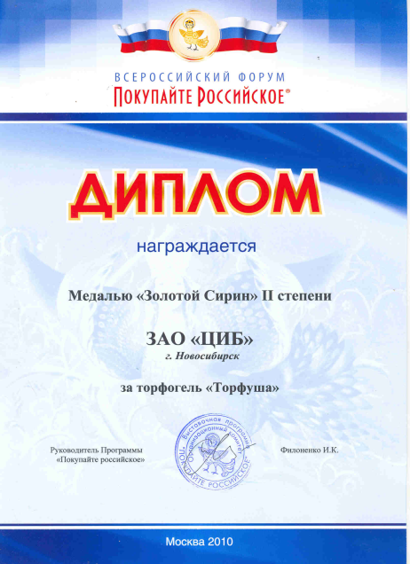

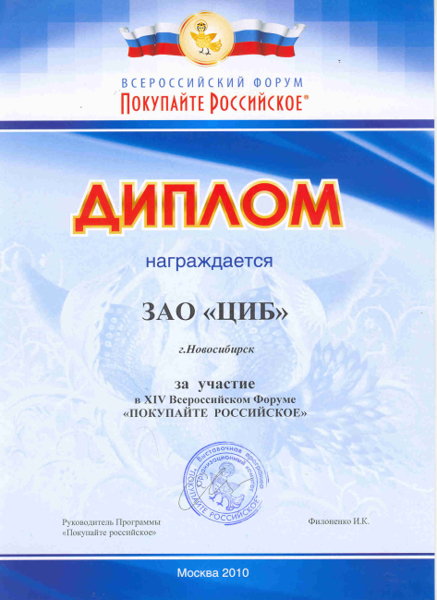

Gold medal “Gold Sirin”

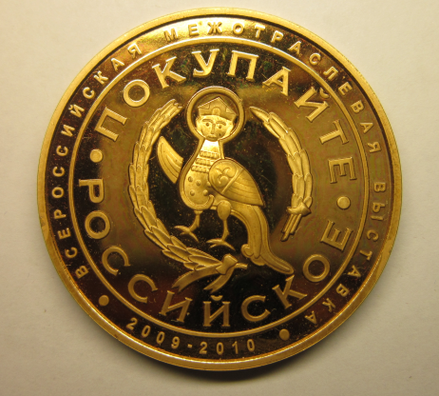

International Agro-Industrial Exhibition-Fair “AGRORUS-2010”
Saint-Petersburg, Russia

DIPLOMA for active participation in Exhibition-Fair
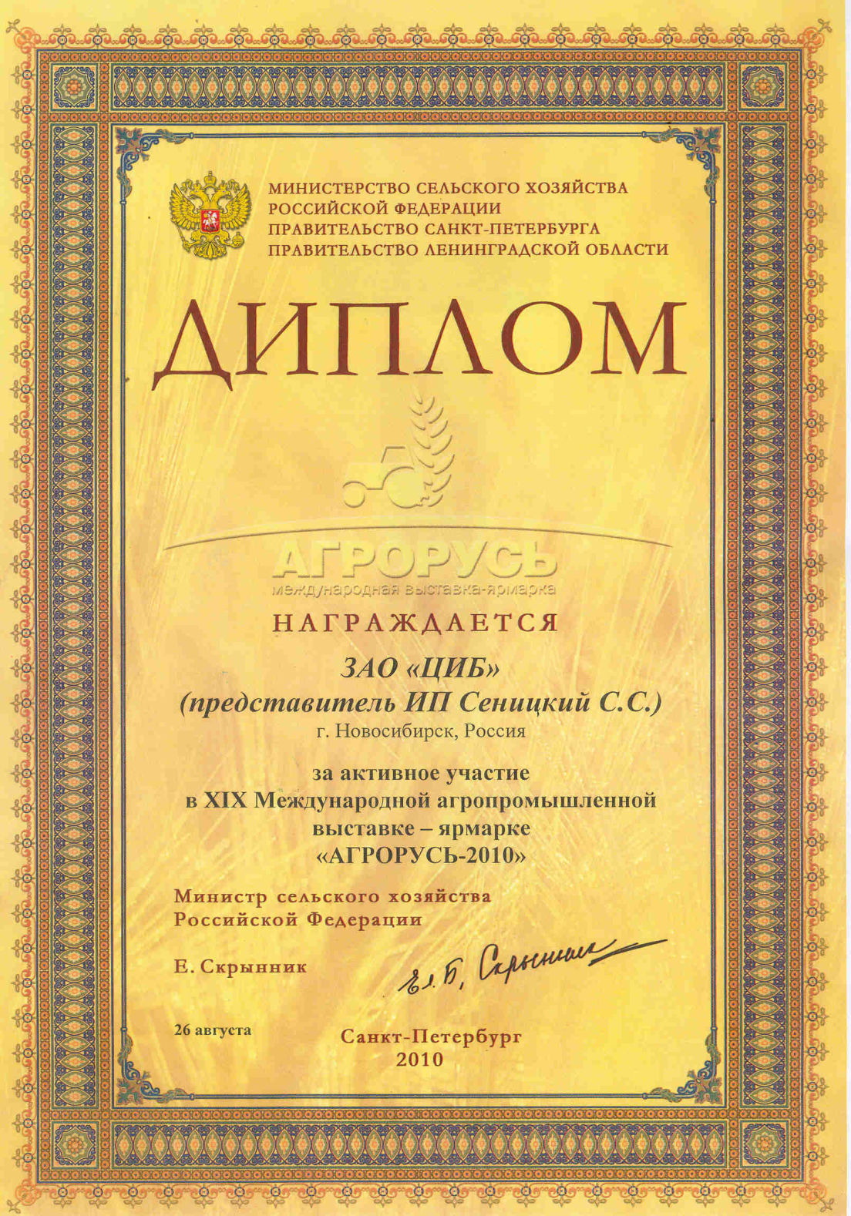

4-th Biotechnological Exhibition-Fair «RusBioTech-2010»
Moscow, Russia

DIPLOMA for creation of an environmentally friendly product
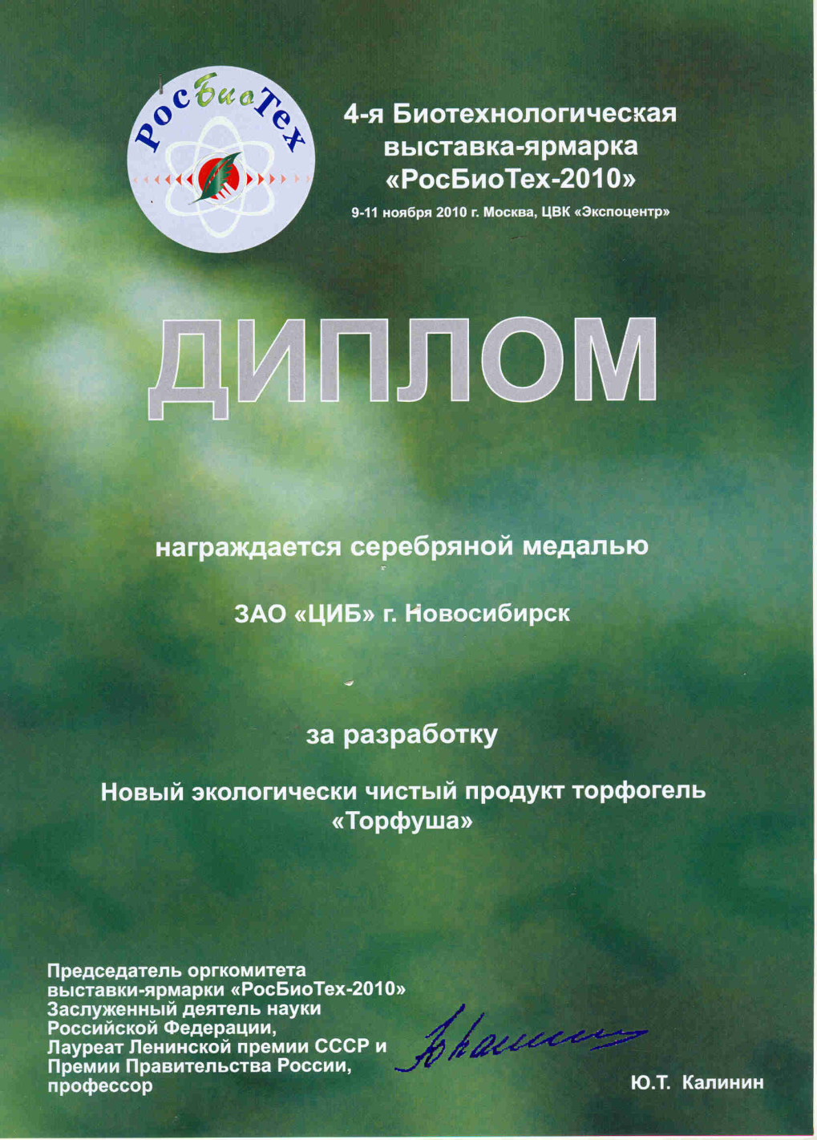

Silver medal
